[**Project Life Cycle**](https://docs.google.com/document/d/1hBnXJnPimM_NRvNizedMh1S4AWzfvMpn/edit#heading=h.1t3h5sf)

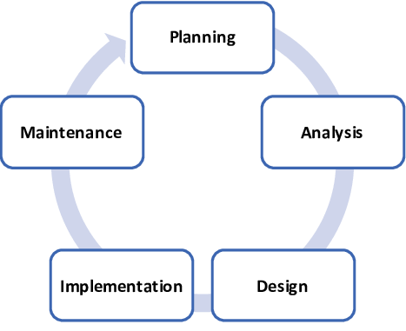.

|  |  |
| --- | --- |
| **phase** | **activities** |
| **planning** | 1. Interview with the client. 2. Produced details project schedule consider network diagram. 3. Determine staff of project. |
| **analysis** | 1. Define system requirement. 2. Confirm project feasibility. 3. Review recommendation with team. |
| **design** | 1. Entity relationship diagram (Erd). 2. Dataflow diagram. 3. Database. 4. Graphic user interface (Gui). |
| **implementation** | 1. verify and test. 2. train the users. 3. install the system. |
| **maintenance** | - after system installation the system maintenance every period of time  To check if the system has a problem or the system need to update. |

**Phase 1:** planning

In this phase the schedule of project determined ,number of tasks and the time that will be needed to finish the tasks.

And consists of two main activities

1-identification of need for a new or enhanced system.

2-investigation and determination of scope.

* Network diagram

We divide project into 14 tasks and give time to each task and illustrate how each task depend on another task using network diagram ,calculate earlist time,latest time ,calculate slack time and critical path.

* Gantt diagram

A graphical representation of a project that show eash task as a horizontal bar whose length proportional to its time for completion

We illustrate how tasks represent on Gantt chart and we use Microsoft project

**Phase 2**: analysis

In this phase,

.One or more system analysts work with different stackeholder

Groups to specific requirements for the new system.

.No programming is done in this phase.

And in this phase illustrate the one time cost of the project , recurring cost ,benefits and decide if we keep going in the project , we calculate wich year will begin to earn money from organization

, calculate break event point, we calculate present and net present value and suppose discount rate 12%

**Phase 3:** design

-in this phase the business requirement are translated into specific technical requirements

-the design for the user interface,database,data inputs and outputs,and reporting and developed here.

-the result of this phase is a system-design document.

**Erd:**

An entity relationship Diagram is a type of flowchart that illustrates how entities such as peoble,objects or concepts relate to each other within a system .Er Diagrams are most ofen used to design or debug relational database in the fields of software engineering.

We use the rules to represent erd , divide hospital to patient that every thing do in hospital add to your record and managers that manage hospital ,nurses ,workers ,security,and link patient with place to know place for each patient , illustrate restaurant and how to deal with patient and pharmacy how to deal with patient ….each entity represent in rectangle shape ,attribute represent in cycle ship and relation represent in rhombus

**Data flow diagram**

A data flow diagram (DFD) maps out the flow of information for any process or system. It uses defined symbols like rectangles, circles and arrows, plus short text labels, to show data inputs, outputs, storage points and the routes between each destination. Data flowcharts can range from simple, even hand-drawn process overviews, to in-depth, multi-level DFDs that dig progressively deeper into how the data is handled. We divide project into modules to become easy to represent dfd we divided into managers , restaurant, security and doctors

We perform 2levels in each module (context, level 0, level 1) and illustrate what the relation, dependences each one to another, we use check box to check person exist the system or not and managers may be hr or receptionist or purchase or financial and security take attends from any person that enter to the hospital ,receptionist add patients to the system ,financial system which can import and export money to the system and purchase system which interested in adding and process places ,devices and furniture which exist in hospital.

**Estimation Methods and Estimates**

| **Estimation Methods and Estimates** | |
| --- | --- |
| Description | [ Best / Most Likely / Worst ] |
| Effort in person-months or person-hours | Person hours |
| Schedule in calendar months | 3 months |
| Budget in dollars | 80.000 $ |
| Level of Uncertainty | 10 % |